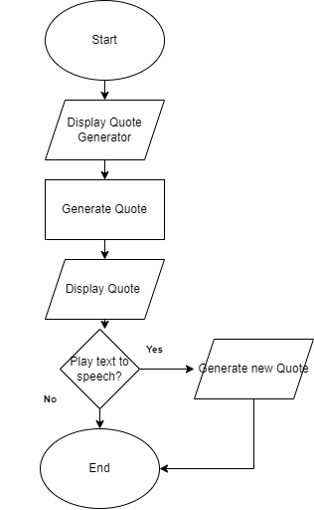

In this diagram it shows after displaying the main page or the quote generator you will have a button that shows “generate quote” when the button is pressed a random quote will be displayed on the screen, after that you will have a button that shows “play audio” this will be an option if you want the text to speech to be played, if not played there will be no audio played and random quotes shall be generated without audio.